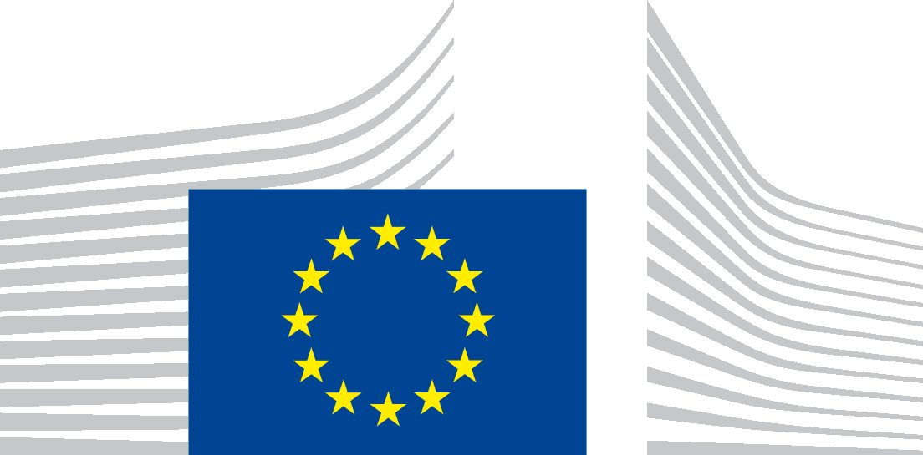 | EUROPEAN COMMISSION  DIRECTORATE-GENERAL FOR MARITIME AFFAIRS AND FISHERIES  FISHERIES POLICY MEDITERRANEAN AND BLACK SEA  CFP AND STRUCTURAL SUPPORT POLICY DEVELOPMENT AND COORDINATION

Inter-Advisory Councils (Inter-ACs) meeting
19 January 2022
from 09:30 to 17:00

Virtual meeting (via INTERACTIO)
Simultaneous interpretation: from FR-EN-IT-ES-BG-RO
into FR-EN-IT-ES-BG

Agenda

Participants: Advisory Councils, Commission (DG Maritime Affairs and Fisheries; DG Environment), observers from the Member States and from the European Parliament
Chair: Lena Andersson Pench, Director MARE.D

09:30 – 10:00 | Opening remarks – Director-General Ms Vitcheva
10:00 – 11:30 | Action plan to conserve fisheries resources and protect marine ecosystems (Joint point MARE/ENV with the participation of Ms Veronica Manfredi, Director Directorate ENV.C Zero Pollution)  Report on the functioning of the CFP and stakeholders consultation (D3)
11:30 – 11:45 | Break
11:45 – 13:00 | Deep-sea access regulation: process leading to the adoption of the implementing act and list of vulnerable marine ecosystems (VMEs) areas in EU waters (C1)  Eels – way forward in view of the November 2021 ICES advice (C1/D1/A2/D3)  New data collection work plans under the new EU MAP - brief presentation on quality annexes in the Work Plans (C3)  Impact of marine wind energy developments on commercial fish stocks (A2/C3)
13:00 – 14:30 | Break
14:30– 15:30 | Potential impact of seismic activities on fish stocks (ENV)  Sustainable blue economy (A3)  Single Use Plastics Directive and operational aspects of the Fishing for Litter Scheme (A1)
15:30 – 15:45 | Break
15:45 – 16:30 | Contingency Plan for ensuring food supply and food security in times of crisis (A2)  EMFAF - state of play of the programming process
16:30 – 17:00 | AOB  The upcoming horizontal initiative on sustainable food systems (A4)  - Taxonomy (D3)

