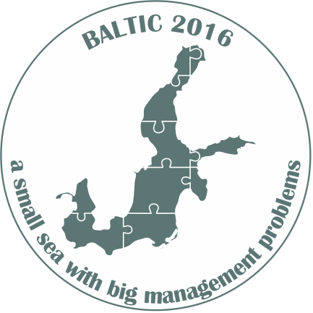

National Marine Fisheries Research Institute
invites for an international symposium:
”Baltic - a small sea with big management problems”
which will be held on 5th October 2016 at 10:00-16:20 at the NMFRI headquarters
in Gdynia ul. Kołłątaja1, Prof. Kazimierz Demel Conference Room

The symposium title refers to the specifics of the Baltic Sea, related problems and conditions concerning: the environment, the different ways of resource management, conflicts between the users of the sea and the opportunities of aquaculture development.
The Scientific Committee, i.e. professors: Piotr Dębowski (Inland Fisheries Institute), Jacek Sadowski (West Pomeranian University of Technology), Jacek Siciński (University of Lodz), Lech Stempniewicz (University of Gdansk), Jan Marcin Węsławski (Institute of Oceanology PAS) and Ryszard Kornijów, Tomasz Linkowski, Marianna Pastuszak, Magdalena Podolska and Iwona Psuty (NMFRI).
All presentations will be held during the plenary session and will be delivered in three thematic blocks: 1. Environment, 2. Management and challenges, 3. Threats.
The symposium will be conducted in Polish and English. The organizers will provide simultaneous translation.
We invite all interested scientists, fishermen and representatives of the fisheries and environment administration.
The participation in the symposium is free of charge but prior registration is required. Detailed information and registration: http://www.sfi.gdynia.pl
Chairman of the Scientific Committee | NMFRI Director
Prof. Tomasz Linkowski | Dr. Emil Kuzebski

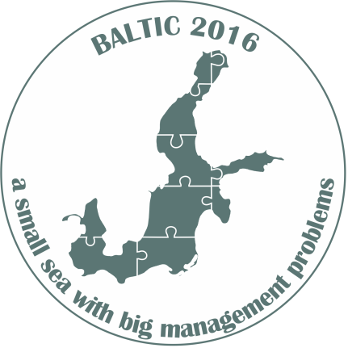

AGENDA
09:30-10:00 Symposium registration & welcome coffee
10:00-10:05 Welcome by Dr. Emil Kuzebski - Director of the NMFRI
Moderator: Prof. Tomasz Linkowski
10:05-10:45 Opening lecture:
- Christian Möllmann - “Regime Shifts Induced by Climate and Overfishing in the Baltic Sea”
10:45-11:25 Session 1- Environment:
- 10:45-11:05 Michael Naumann, Günther Nausch and Volker Mohrholz “The intense inflow activity since 2014 - a succession of four major events and their impact on the Baltic Sea ecosystem”
- 11:05-11:25 Marianna Pastuszak “Eutrophication of the Baltic Sea - problem seen from different prospects”
11:25-12:00 Coffee break
12:00-13:20 Session 2 - Management and challenges:
- 12:00-12:20 Michael Anderson “Review of fisheries management system in the Baltic states - The road to hell is paved with good intentions”
- 12:20-12:40 Anna Wąs “Genetics as a useful tool in stock management; whitefish example”
- 12:40-13:00 Anton Paulrud “Right-based management system in Baltic - results and experiences”
- 13:00-13:20 Jacek Sadowski “Prospects for the development of mariculture in the Polish zone of the Baltic Sea”
13:20-14:30 Lunch
14:30-15:40 Session 3 - Threats:
- 14:30-14:50 Marguerite Tarzia “Bird bycatch in Baltic gillnet fisheries - the search for solutions”
- 14:50-15:10 M. Podolska, J. Horbowy, K. Nadolna-Ałtyn “Perils of the sea - parasites transmitted by seals”
- 15:10-15:30 Staffan Waldo “Economic effects of seal damages in Swedish coastal fisheries”
- 15:30-15:50 Iwona Psuty “Fisheries in the context of spatial conflicts in the Polish Marine Areas”
15:50-16:20 Symposium summary and discussion

